Layla Swift
SEC 250
Nmap Lab
Oct 22, 2026
- Setup: 10.0.17.12
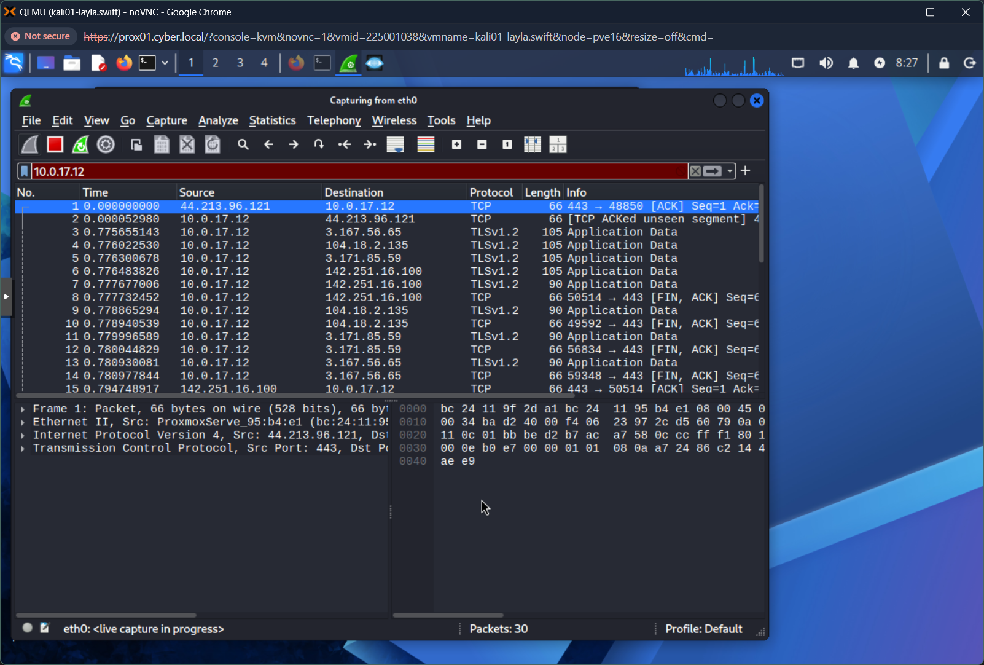
Nmap:
- 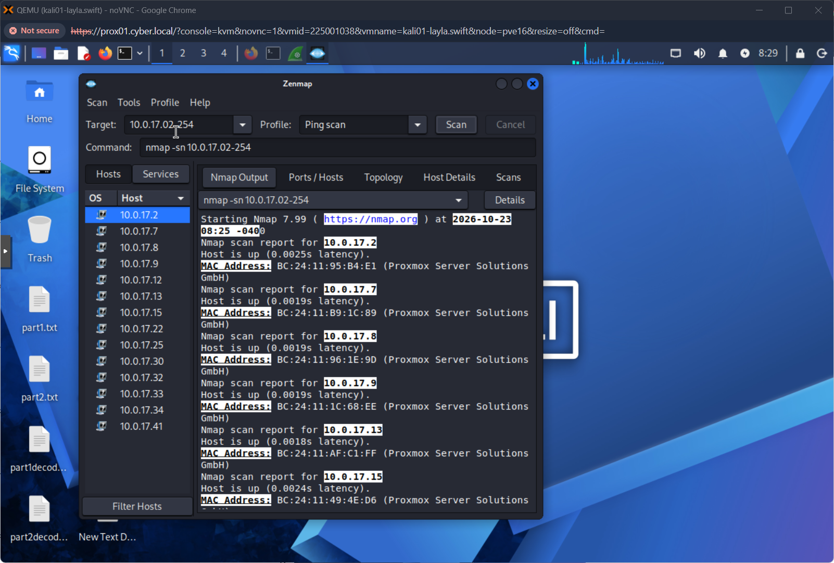
- 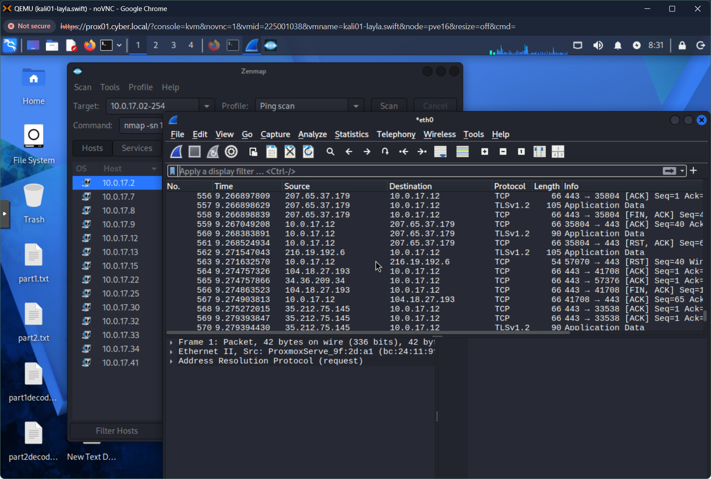
Deliverable 1:

-sV | Probe open ports to determine service/version info
-T4 | Set timing template (0-5) where higher number is faster
-O | Enable OS detection
-F | Fast mode - scan fewer ports than the default scan

Deliverable 2:
- 10.0.17.33
- Ports 80, 135,139, 445
- Port 80: HTTP, Port 135: RPC, Port 139: NetBIOS, Port 445: SMB
- Windows 10|11, probably 10
- 100 filtered ports
- 96 closed ports
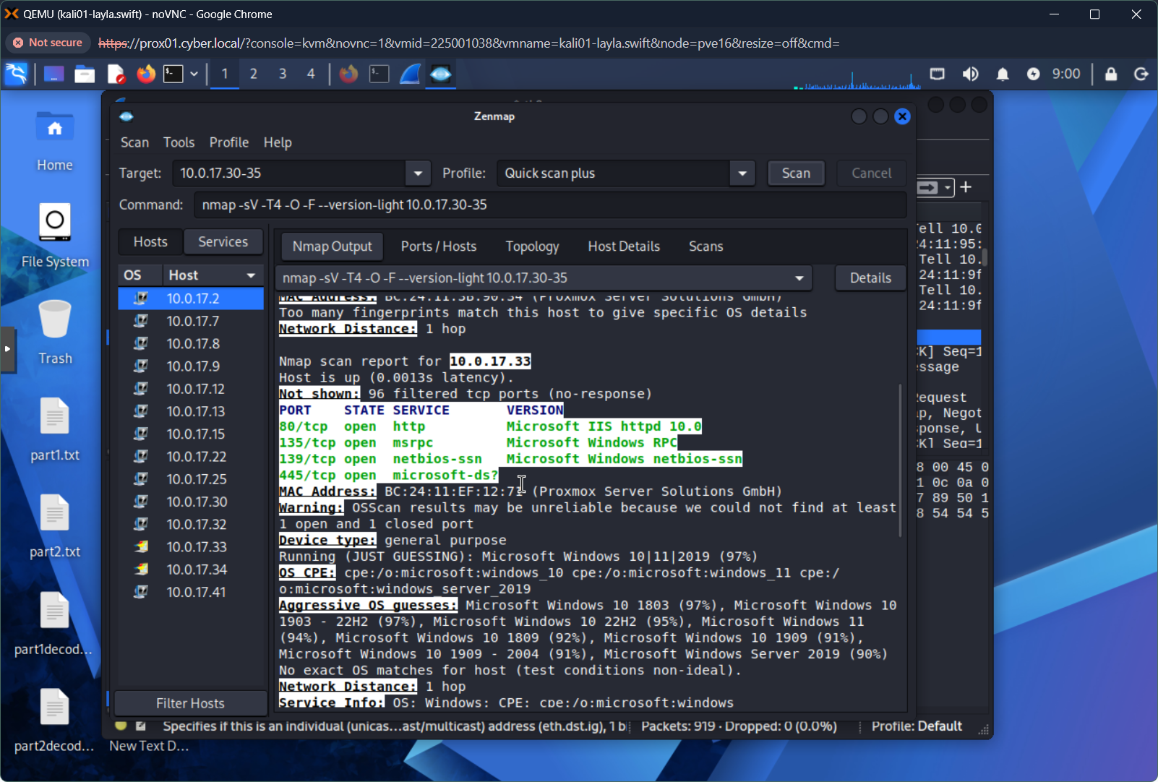
- 10.0.17.34
- Port 80, Port 3389
- Port 80: HTTP, Port 3389: RDP
- Windows 10|11, probably 10
- 100 filtered ports
- 98 closed ports
Deliverable 3:
- The scan found an additional port open on 10.0.17.33, Port 137. This port is used by NetBIOS Name Services. This is a legacy protocol that translates computer names into IP addresses on a LAN. It was scanning a total of 4000 ports, and 2626 services on 4 hosts. I also came back to this later and found an open port 500 on 10.0.17.41, an open port 123 on 10.0.17.2, and an open port 53 on 10.0.17.2
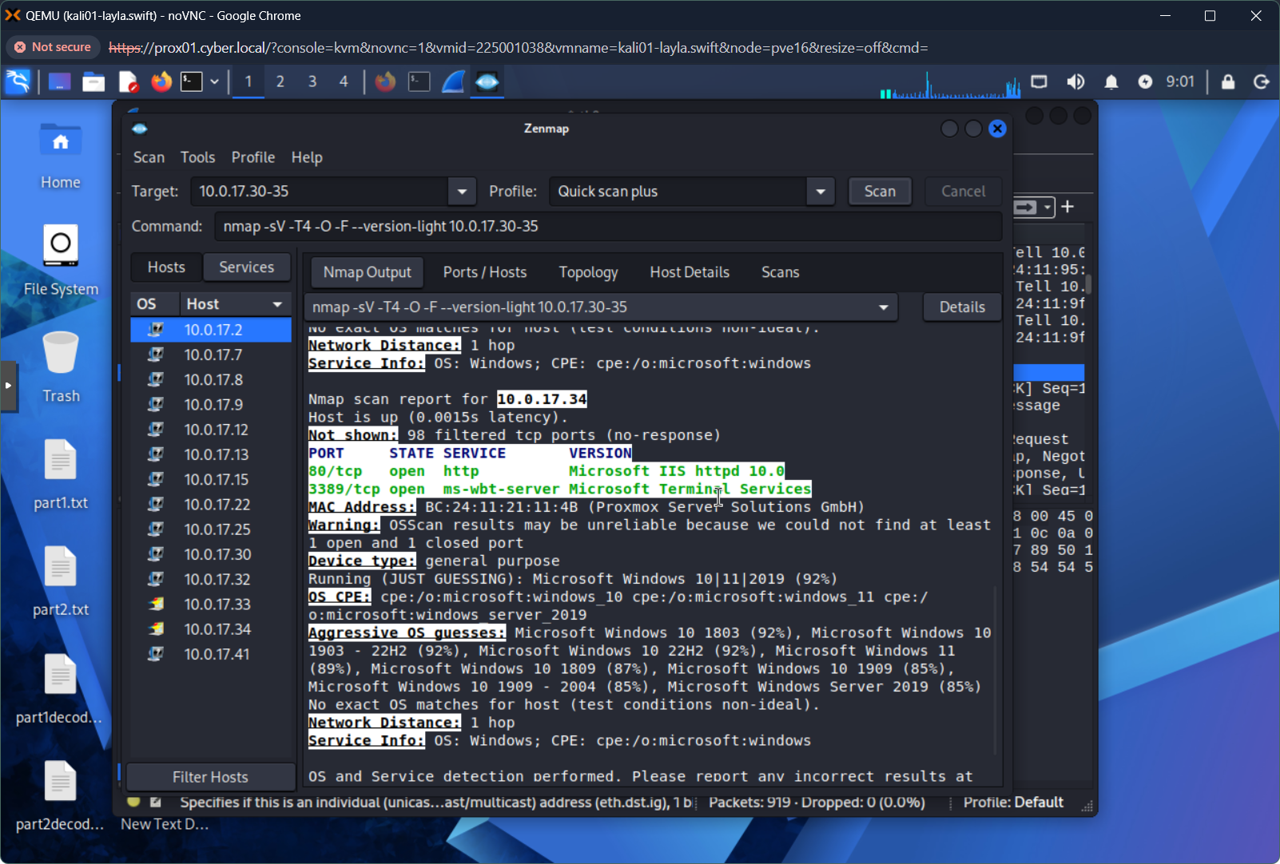
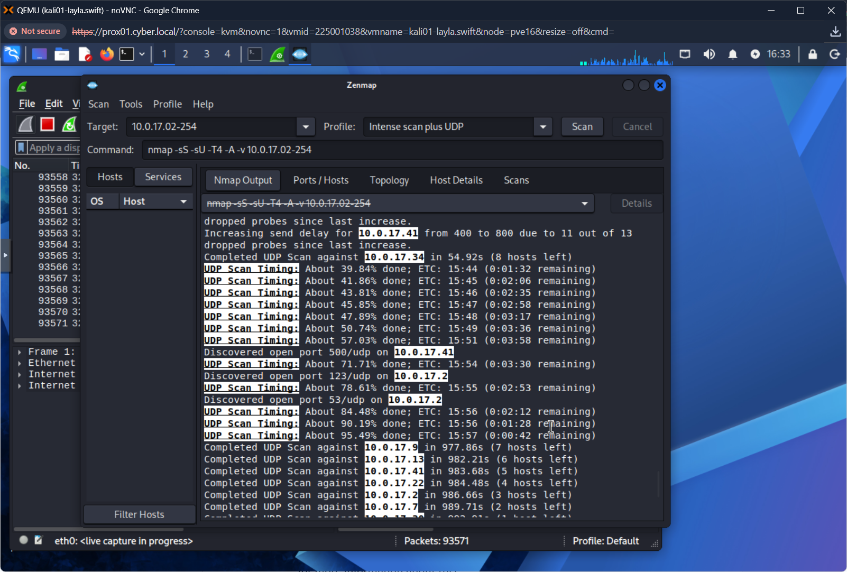
Deliverable 4:
- There is a 3-way handshake with IP 10.0.17.34 on port 3389. Yes, it’s open!
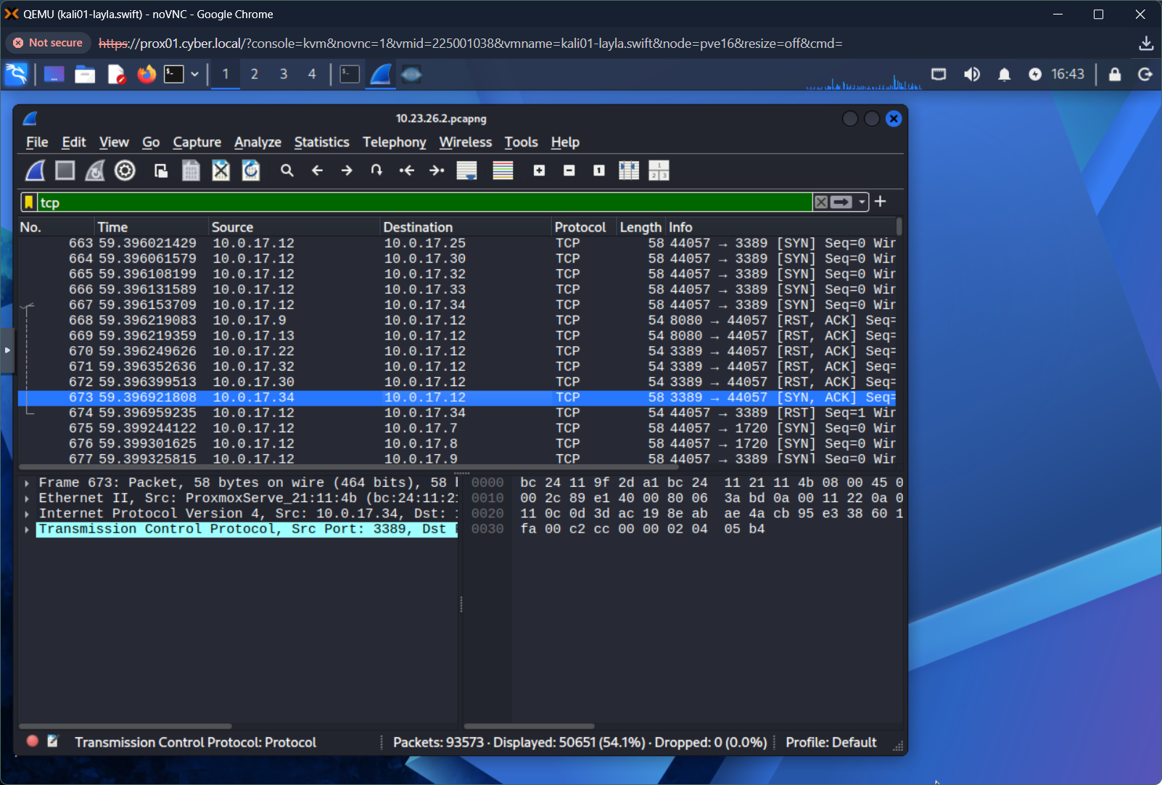
Another 3-way handshake with IP 10.0.17.33 on port 445. Yes, it’s open!
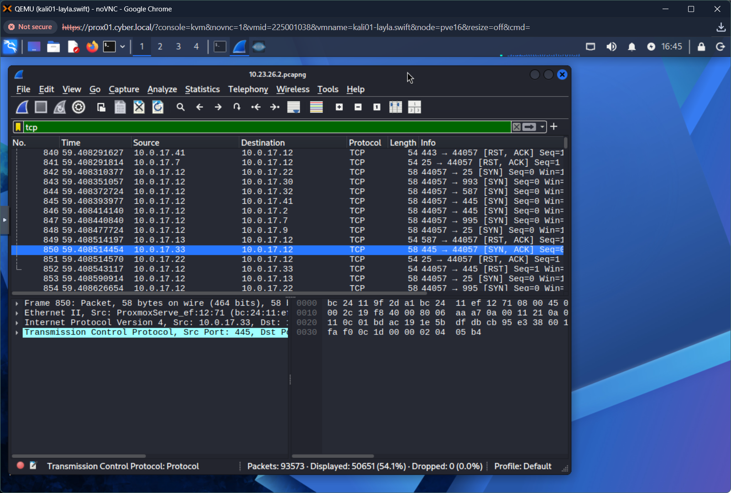
- Yes, I found some netcat traffic.
It was using TCP on source port 53, destination port 58412
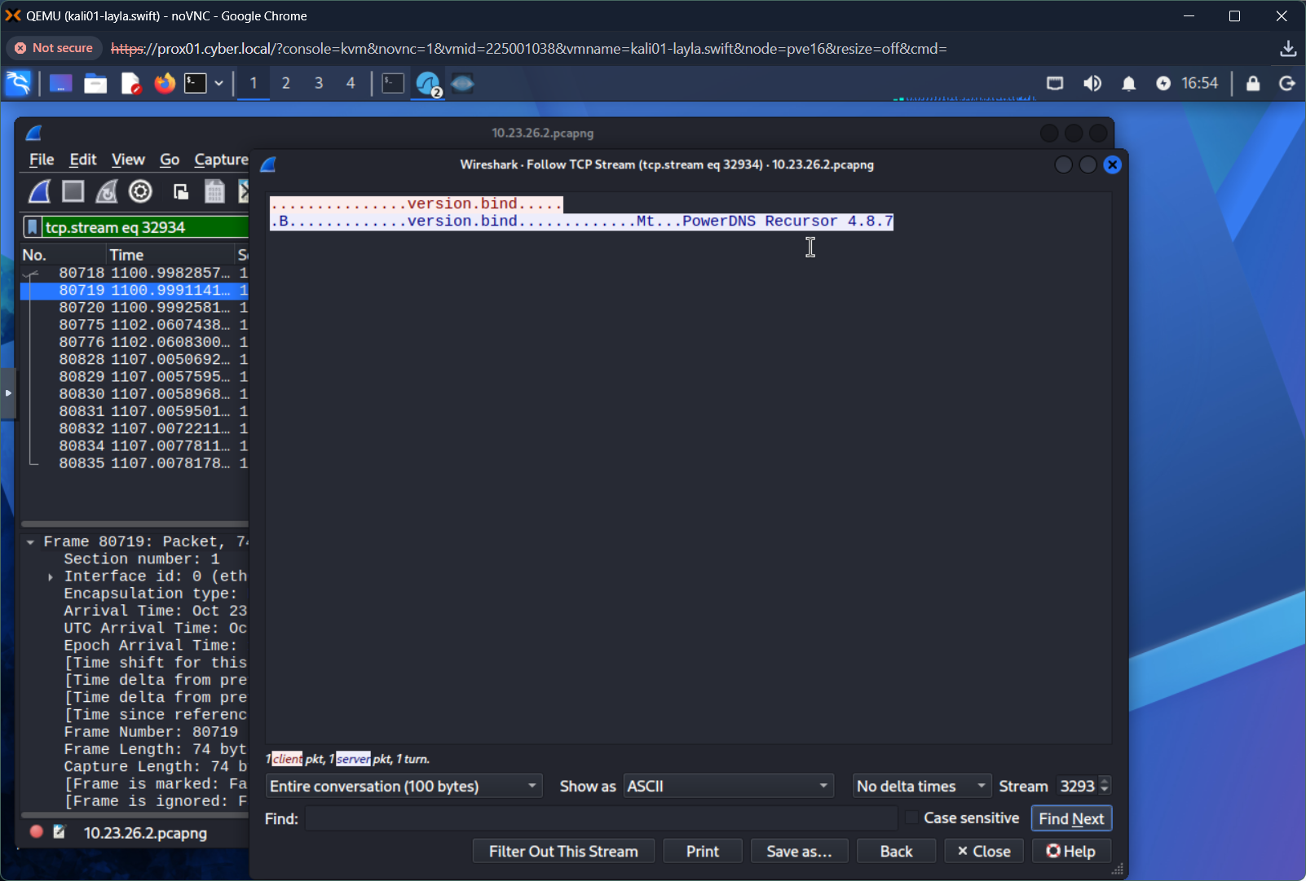
- Two ways I might notice a scan: first, lots of packets. There seem to be a lot of RST packets. Second, even when a 3-way handshake succeeds, nothing comes through. Empty packets seem suspicious, like someone is testing which ports are open.
- When I opened the I/O graphs under statistics, I saw clear peaks. I thought that showed where Nmap is active.
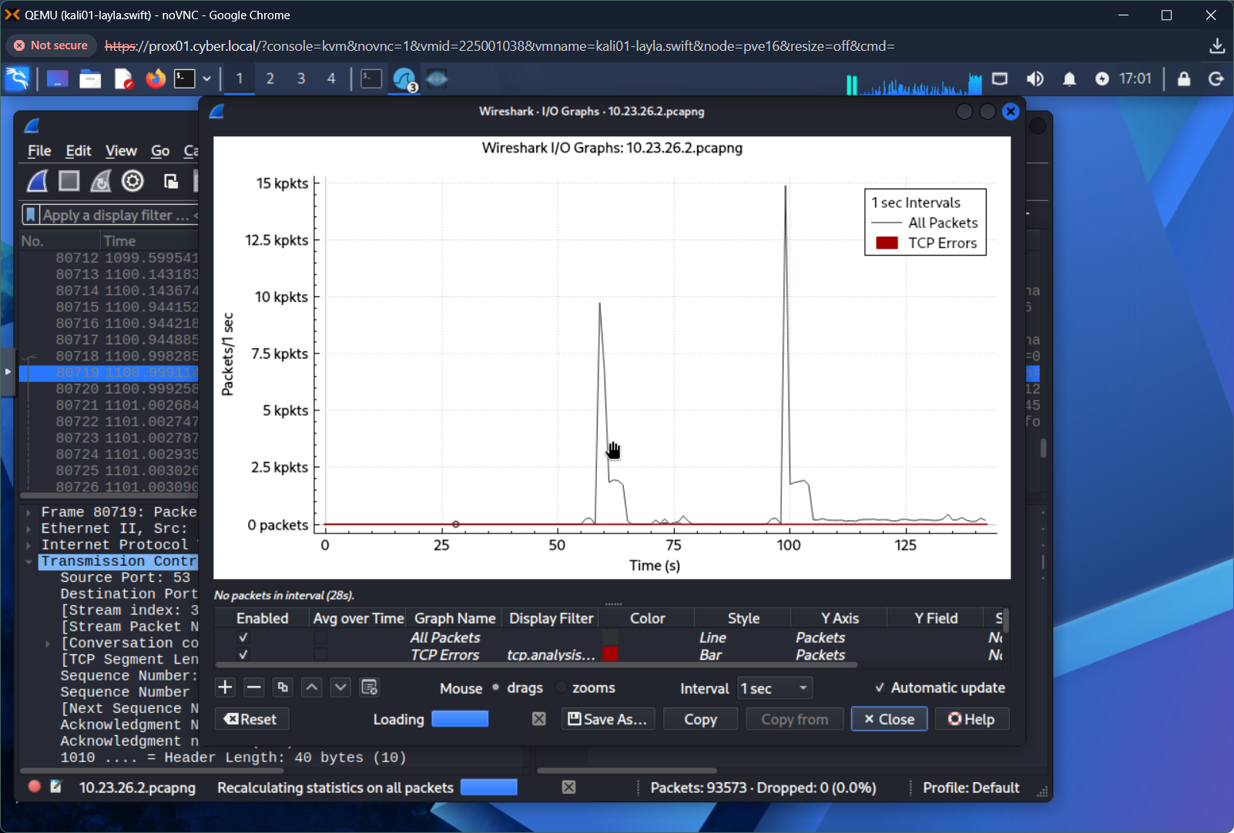
Deliverable 5: Research and Reflection
- I think the top three security risks are: exposed ports, running netcat, and the risks associated with remote scanning of the entire system. This lab demonstrates how easily someone could find all your open ports, closed ports, etc. Also, netcat seems wildly dangerous! To handle these risks, encrypt so that netcat can’t work (would that work?), set up firewalls (as we know from the network security lab, a single computer could block any access if the firewall is set up that way), and block anyone who spams you with too much traffic. I think those things would help mitigate these issues.
- Scanning benefits both attackers and defenders by keeping everyone aware of what is going on. Keeping track of this information can give you a baseline (defender), and it can also help you identify open and closed ports and map a system (attacker). Regular security audits are essential to keep track of changes in network activity!
- Quick scan plus seems faster and less detailed. It gives you a general idea without too much detail. Intense scan takes a LONG time! However, it catches a lot of information that a quick scan might miss. Real-world use depends on what is needed. Mapping a system might be best with a quick scan or penetration testing. Deep-dive auditing of a system might require the long, intense scan, though.
- Filtered ports show up as open or closed. If there is a 3-way handshake, it’s open; if not, you get RSTs. Filtering may show also show that a firewall has been set up, depending on the network policy. I think?
- Scanning a network or system without permission may be illegal! If you are doing this for work, do not break the law! If you are hired as a pen tester, this may be allowed, but they always have explicit rules and policies for this type of work. Breaking the law could lead to fines, prison, jail, lawsuits, etc. It could also disrupt the network if you do this at the wrong time! It’s just not worth it to do unless directed to do so for work.

